Ryan G. Cooper

Professor Conlan

CS-405 Module 2 Assignment Three

May 19th, 2024

**Securing Code from Buffer Overflow**

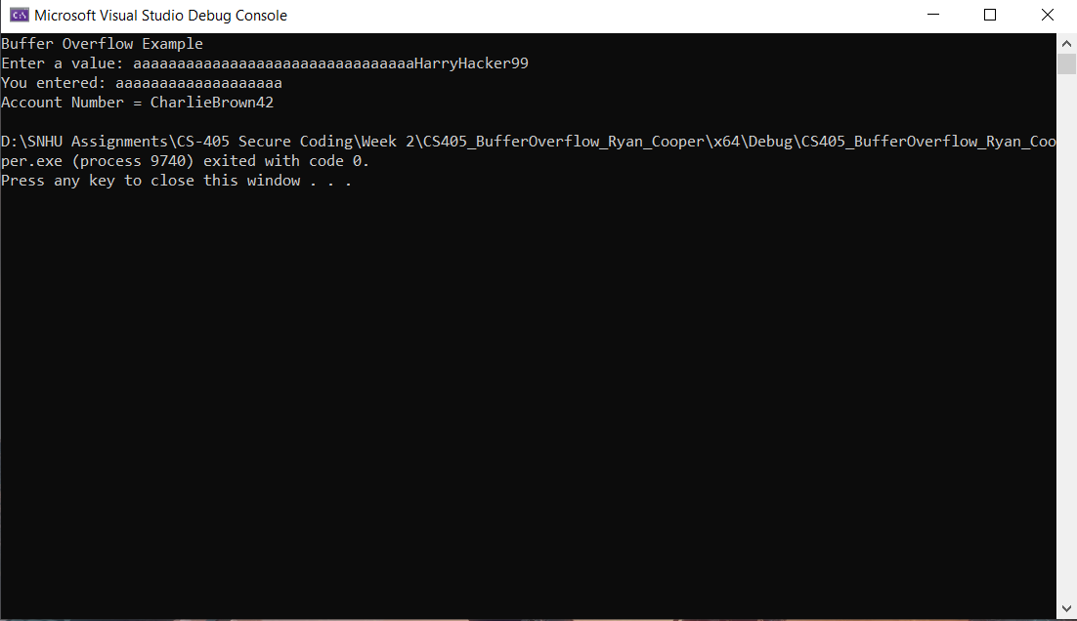

This screenshot shows the output of the fixed Buffer Overflow code. The fix works by using the get function on cin to get the first 20 characters. Then an if statement is used to check if a buffer overflow occurred, if so, a flag is raised by the system. The flag is cleared and only the max number of characters, in this case 20, starting at the first character is stored. The other characters are discarded from the input. This way nothing is overwritten in the system, and it no longer crashes either.